Using loc, iloc and ix

There are three ways to select data from a data frame in Pandas: *loc*, *iloc*, and *ix*.

loc

*loc*is primarily label based; when two arguments are used, you use column headers and row indexes to select the data you want. *loc*can also take an integer as a row or column number.

Examples of *loc*usage:

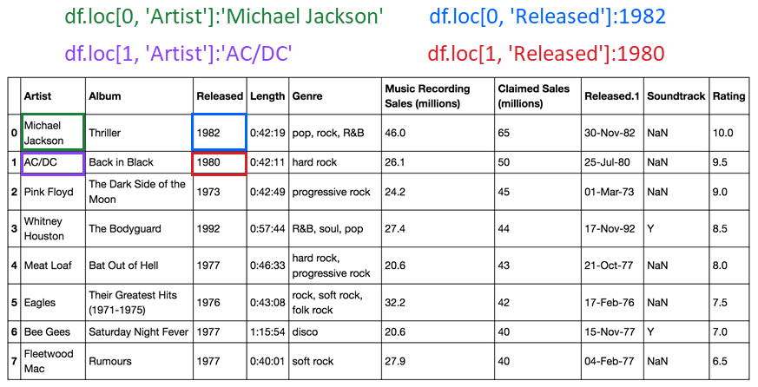

*loc*will return a *KeyError*if the requested items are not found.

iloc

*iloc*is integer-based. You use column numbers and row numbers to get rows or columns at particular positions in the data frame.

Examples of *iloc*usage:

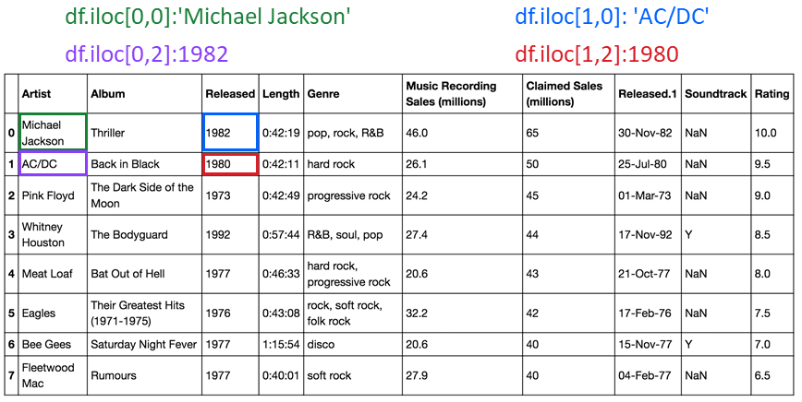

*iloc*will return an *IndexError*if the requested indexer is out-of-bounds.

ix

By default, *ix*looks for a label. If ix doesn't find a label, it will use an integer. This means you can select data by using either column numbers and row numbers or column headers and row names using *ix*.

In Pandas version 0.20.0 and later, *ix*is deprecated.

Using loc and iloc for slicing

You can also use *loc*and *iloc*to slice data frames and assign the values to a new data frame.

Creating a new dataframe with loc slicing

You can also slice data frames and assign the values to a new data frame using the column names. The code assigns the first three rows and all columns in between to the columns named Artist and Released. The result is a new data frame Z with the corresponding values.

https://d3c33hcgiwev3.cloudfront.net/imageAssetProxy.v1/8QAiQjs-RCaAIkI7PgQmhw_5e72f5c7aa18df4d8574986fd854bf47_DS_4.4.3.1a-loc-slice-formula.png?expiry=1591488000000&hmac=5j_x0I5Wl1bW7Kex2dYhSErBC4-23Xl21QDNxFMdjgM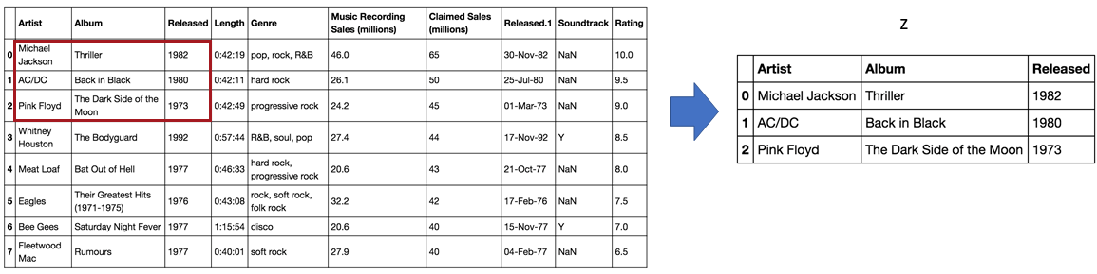

Creating a new dataframe with iloc slicing

In this example, we assign the first two rows and the first three columns to the variable Z. The result is a data frame comprised of the selected rows and columns.

